Question 1: CLO-01 [5x2=10 points]
Consider the scenario shown below in which Alice sends an email to Bob. Assume both Bob's and Alice's user agents use the HTTP protocol.
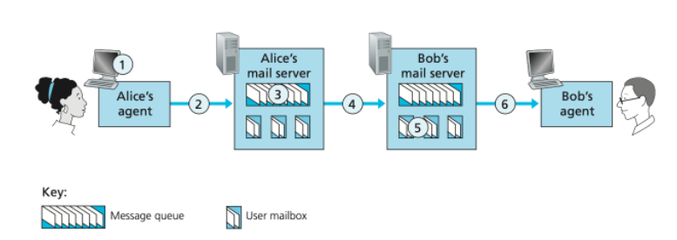
- At point 2 in the diagram, what protocol is being used? SMTP
- At point 4 in the diagram, what protocol is being used? SMTP
- At point 6 in the diagram, what protocol is being used? HTTP
- Is SMTP a 'push' or 'pull' protocol? Push
- Is HTTP a 'push' or 'pull' protocol? Pull

Question 2: CLO-01 [2x5=10 points]
- Suppose you have just created an exciting new startup company called Network Utopia. You have to register the domain name at the registrar. Provide names, IP addresses of authoritative name server (primary and secondary) and write DNS Records that the registrar would insert into the DNS system. Suppose the IP address over which the domain is hosted is 212.212.212.1.
Solution
(networkutopia.com, dns1.networkutopia.com, NS)
(dns1.networkutopia.com, 212.212.212.1, A)

- Consider the following network. With the indicated link costs, use Dijkstra’s shortest-path algorithm to compute the shortest path from x to all network nodes. find the least cost path tree from source node x to all other destinations. Show how the algorithm works by computing a table.
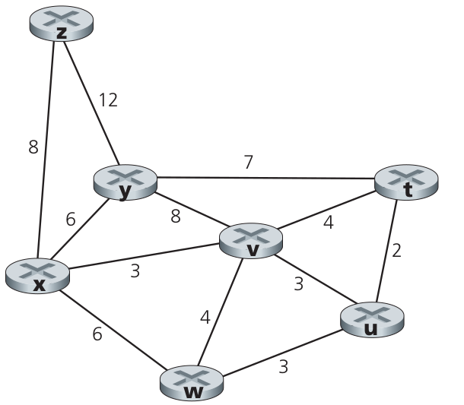
Solution:
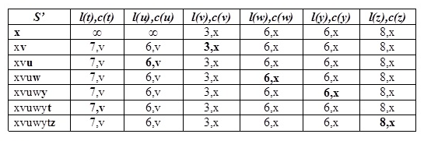

Question 3: CLO-01 [10 points]
Write down the steps of how BGP will advertise the reachability information for prefix x to all of the routers.

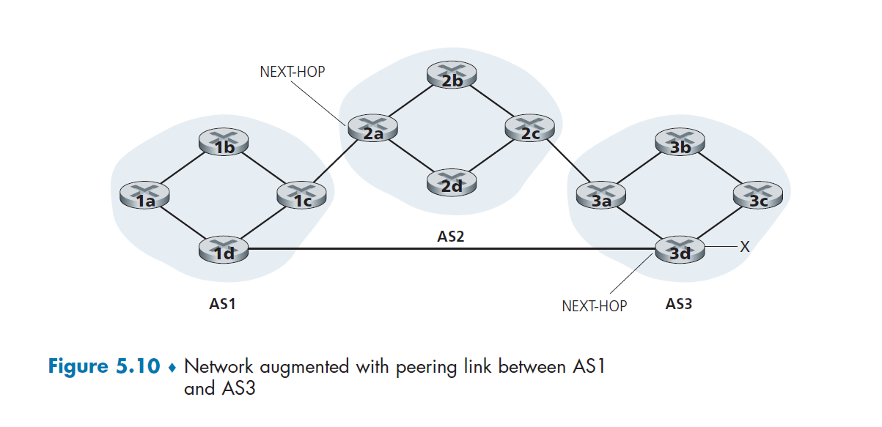
SOLUTION
AS2 router 2c receives path advertisement AS3,X (via eBGP) from AS3 router 3a based on AS2 policy, AS2 router 2c accepts path AS3,X, propagates (via iBGP) to all AS2 routers based on AS2 policy, AS2 router 2a advertises (via eBGP) path AS2, AS3, X to AS1 router 1c

Question 4: CLO-01 [5x2=10 points]

Write the difference, in maximum 30 words each (answer will not be marked after 30 words)
a) Software Defined Network versus Network Function Virtualization
b) Length field of TCP Header versus the Length field of IPv4 Header
c) Checksum Field of UDP Header versus the Header Checksum Field of IPv4 Header
d) Forwarding versus Routing
e) Speed of convergence of Link State versus Distance Vector

Solution:

a) Software Defined Network versus Network Function Virtualization
SDN: (logically) centralized control and configuration management often in private/public cloud
network functions virtualization (NFV): programmable services over white box networking, computation, storage

b) Length field of TCP Header versus the Length field of IPv4 Header
No difference. Both are length of header (segment or datagram) plus payload.

c) Checksum Field of UDP Header versus the Header Checksum Field of IPv4 Header
UDP Checksum is calculated on Header plus payload, while Ipv4 Header Checksum is calculated only on header fields of IPv4 Datagram.

d) Forwarding versus Routing
forwarding: data plane function: move packets from router’s input to appropriate router output
routing: control plane function: determine route taken by packets from source to destination

e) Speed of convergence of Link State versus Distance Vector
LS: O(n^2) algorithm, O(n^2) messages, may have oscillations
DV: convergence time varies, may have routing loops, count-to-infinity problem

Question 5: CLO-02 [3 + 4 +3 = 10 points]
- In network-assisted congestion control, how is congestion in the network signaled to the sender?
- In end-end congestion control, how is congestion in the network signaled to the sender?
- Name one protocol that uses an end-end congestion approach?
Solution:
- Routers may set bits in passing packets and may send messages to the source or destination to indicated congestion.
- Congestion is inferred at the end hosts (sender or receiver, either as a result of packet loss or increased delay).
- TCP uses an end-end approach.

Question 6: CLO-03 [5 +5 = 10 points]

- Consider an application that uses rdt 3.0 as its transport layer protocol, which is a reliable, error-correcting stop and wait protocol. Assume that the sender sends two packets with sequence numbers 0 (pkt0) and 1 (pkt1). Among them, a packet with sequence number 1 is lost. Demonstrate with the help of a sequence diagram how rdt 3.0 recovers from that packet loss?
- Suppose a packet is 10K bits long, the channel transmission rate connecting a sender and receiver is 10 Mbps, and the round-trip propagation delay is 10ms. What is the maximum channel utilization of a stop-and-wait protocol for this channel?

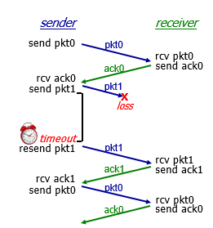
Solution (a):

Solution (b):
Using below formula channel utilization will be 0.1
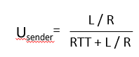

Question 7: CLO-03 [3 + 4 +3 = 10 points]
Consider there is only one router, with finite buffer capacity. The input and output link capacity of router is R. Two flows are attached to the router, each flow sharing half of the router capacity and each flow have:
(i) the perfect knowledge of the router buffer capacity.
(ii) have partial knowledge, and knows only if the packet is dropped at the router (retransmission needed for lost packet).
(iii) have no knowledge about router buffer, nor about any dropped packet (guess only by acknowledgement packets).
Plot the graphs for each of the above case for only one flow, showing transport-layer input on x-axis and maximum achievable receiver throughput at y-axis.

Solution:
R/2
λ_{in}
R/2
λ_{out}
throughput:
“wasted” capacity due to retransmissions
when sending at R/2, some packets are needed retransmissions

λ_{in}
R/2
λ_{out}
throughput:
R/2

λ_{in}
R/2
λ_{out}
throughput:
R/2

“wasted” capacity due to un-needed retransmissions

when sending at R/2, some packets are retransmissions, including needed and un-needed duplicates, that are delivered!

Question 8: CLO-03 [4x2.5 = 10 points]
SDN provides a programmable control plane, however, it network infrastructure needs changes as we studied in chapter # 5 of our textbook. Now, answer the following questions.
- How the data plane is different while using SDN? Explain.
Two fold: i) data plane is based on SDN controlled switches and ii) uses flow table to forward traffic.

- What is the key role of OpenFlow in SDN?
OpenFlow defines the communication protocol between SDN controllers and the data (forwarding) plane. It facilitate SDN controllers to send messages to switches consisting of queries, setting configuration parameters, modify state and even sending packets directly. Similarly, switch can send port and flow table status, or packets for processing at the controller.

- Setup a flow table entry which prefers traffic from an IP telephone. Make suitable assumptions.
Match plus action type generalized forwarding. IP telephone traffic can be identified using Layer 2 attributes (MAC address or VLAN ID) or Layer 3 attributes (e.g. source or destination IP address).

Match [IP Scr=10.20.30.*, optionally IP Dest= 172.16.20.*]
Action [send to controller for type of service setting]

- How SDN controller (explain in a step-by-step way) make use of different network application to provide link state routing in the SND setup? Explain.

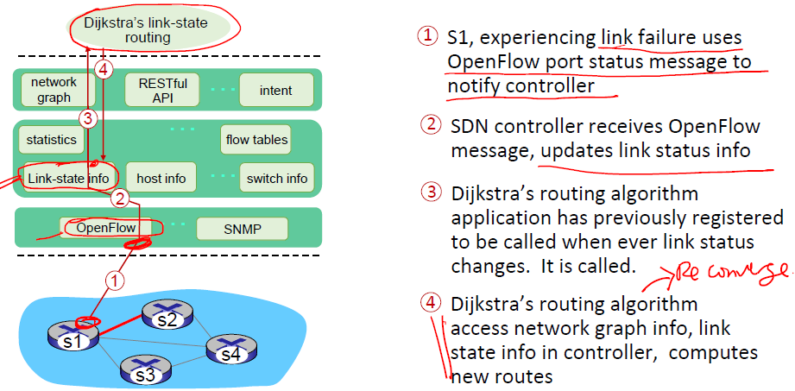
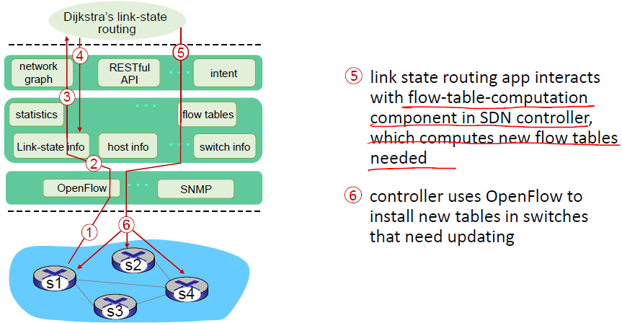

Question 9: [CLO-3] [4+3+3=10 points]
Consider a two LAN connected by a router as shown in Figure 4. 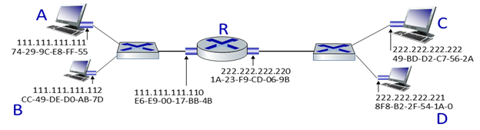
- Host A transmits a packet to host D. Which Layer 2 and Layer 3 addresses are contained in the protocol data units that are transmitted from host B to the router?
Answer:
Layer 2 destination address = E6-E9-00-17-BB-4B
Layer 2 source address = 74-29-9C-E8-FF-55
Layer 3 destination address = 222.222.222.221
Layer 3 source address = 111.111.111.111

- Host A wants to get the MAC address of Host C, which protocol Host A will use to find the C’s MAC address? What is the purpose of that protocol?
Answer:
Host A uses ARP to find Host C’s MAC address. The purpose of ARP is to obtain a specific MAC address when an IP address is known, by broadcasting an ARP request message to all devices on a particular Ethernet network

- Host B issues an ARP request because it want to send a packet to Host D. what will happen next?
Answer:

When Host D receive the ARP request, it will send an ARP reply with its MAC address

Question 10: [CLO-3] [10 points]
Because of the connection-oriented nature of TCP, a connection setup phase is required at the beginning of each session, as well as a connection tear-down phase at the end of the session. Enumerate the events below in the order they occur as host A opens a TCP connection to host B, transmits data and then closes the connection. Write a 1 next to the event that occurs first and continue like that until all occurring events are enumerated (the first event has been enumerated for you). You may assume that no segments are lost. Also indicate at which host the event happens. Please note that there might be events listed below that are not a part of the above data transfer and hence should not be enumerated. [10 points]

